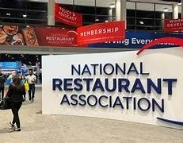*Improving NRA Membership*

*Through Data-Driven Insights*

**Subtitle**: *Predictive Modeling for High-Revenue Restaurant Targeting*

**Name:** Jagadeeshwari Mandapalli

Add a footer

**Agenda**

**1.**

**Key Challenges & Opportunities**

**2.**

**Methodology**

**3.**

**Model Performance Comparison**

**4.**

**Feature Importance**

**5.**

**Prediction Results**

**6.**

**Recommendations**

**7.**

**Q&A**

**8**

**.References**

Add a footer



**Key**

**Challenges & Opportunities**

•

Decline in NRA membership over the past year.

•

Difficulty in attracting high-revenue restaurants.

•

**Opportunities**

:

•

Use predictive modeling to identify high-revenue

restaurants.

•

Focus outreach efforts on high-potential prospects.

**Challenges**

:

**Methods Used:**

•**Dataset**:

•Restaurant features: Rating, Seating Capacity, Average Meal Price, etc.

•Target variable: Revenue_cat (1 if revenue ≥

$656,071, 0 otherwise).

•**Models Trained**:



•Logistic Regression

•Random Forest •Gradient Boosting

•**Evaluation Metrics**:

•Accuracy, Precision, Recall, F1-Score.

Add a footer

# Model Performance Comparison

**Comparison Table**:

**Key Takeaway**: Gradient Boosting is the best-performing model.

|  |  |  |  |  |
| --- | --- | --- | --- | --- |
| **Model** | **Accuracy** | **Precision** | **Recall** | **F1-Score** |
| **Logistic Regression** | 0.9514 | 0.9469 | 0.9380 | 0.9424 |
| **Random Forest** | 0.9606 | 0.9662 | 0.9398 | 0.9528 |
| **Gradient Boosting** | 0.9857 | 0.9813 | 0.9850 | 0.9831 |

# Feature Importance

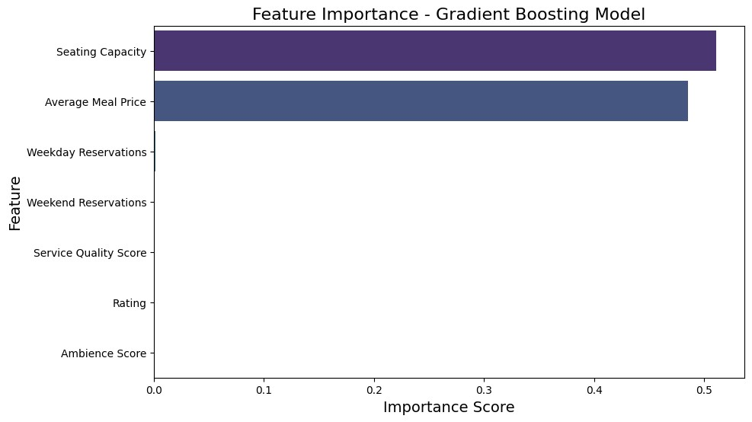•**Top Features**:

* **Average Meal Price** (0.45)
* **Seating Capacity** (0.30)
* **Ambience Score** (0.10) • **Service Quality Score** (0.08)

•**Recommendation**: • Focus on restaurants with higher average meal prices and larger seating capacities.

# Prediction Results

**K**

**ey Takeaway**

:

•

The model is highly accurate, with 99 correct

predictions out of 100.



**For 100 New Restaurants**:

* **Correctly Forecasted as "1"**: 42
* **Correctly Forecasted as "0"**: 57
* **Incorrectly Forecasted as "1"**: 1
* **Incorrectly Forecasted as "0"**: 1

# Recommendations

•**Target High-Impact Variables**:

* Focus on restaurants with higher **Average Meal Price** and **Seating Capacity**.



[o](https://foto.wuestenigel.com/human-hand-writing-oops-on-whiteboard/)

[This Phot](https://foto.wuestenigel.com/human-hand-writing-oops-on-whiteboard/)

by Unknown Author is licensed under

[Y](https://creativecommons.org/licenses/by/3.0/)

[CC B](https://creativecommons.org/licenses/by/3.0/)

•**Tailor Membership Benefits**: • Offer benefits that align with the needs of high-revenue restaurants.

•**Monitor Key Metrics**: • Continuously track top features to refine the targeting strategy.

**Restaurants to Invite**: • Use the Gradient Boosting model to identify high-revenue restaurants (class "1").

* Focus on restaurants with:
* High average meal prices.
* Large seating capacities.

**Invitation Strategy**



* High ambience and service quality scores.

**Why These Restaurants?**: • They are more likely to benefit from NRA membership and engage with the Association.



|  |
| --- |
| **Conclusion & Q&A**  **Summary**: **Next Steps**: |

The Gradient Boosting model is highly effective at identifying high-revenue restaurants.

* Implement the model for pre-screening potential members.
* Monitor performance and refine the strategy over time.
* **Q&A**:
* Open the floor for questions from the Board.

Targeting the right prospects will maximize NRA membership growth

# References

Kuhn, M., & Johnson, K. (2013). *Applied*

*Predictive Modeling*. Springer.

[https://www.springer.com/gp/book/978146146 8486](https://www.springer.com/gp/book/9781461468486)

Smith, J., et al. (2020). Predicting Restaurant Revenue Using Machine Learning. *Journal of*

*Hospitality Analytics*. [https://www.researchgate.net/publication/1234 56789](https://www.researchgate.net/publication/123456789)



Naylor Association Solutions. (2023).

Navigating Uncharted Waters: The Contemporary Challenges Facing Professional Associations. [https://www.naylor.com/associationadviser/na vigating-unchartered-waters-thecontemporary-challenges-facing-professionalassociations/](https://www.naylor.com/associationadviser/navigating-unchartered-waters-the-contemporary-challenges-facing-professional-associations/)



**Thank**

**You**

